American International University- Bangladesh
Department of Computer Engineering
COE 3201: Data Communication Laboratory
Part-1
Title: Study of Amplitude Modulator and Demodulator using Simulink
Abstract:
This experiment is designed to-

- To understand the use of Simulink for AM modulation.
2.To develop understanding of AM demodulation.
Introduction:
Amplitude modulation (AM) is a one of the conventional technique used to transmit message signals using a carrier wave. The amplitude or strength of the high frequency carrier wave is modified in accordance with amplitude of the message signal.
- Carrier signal (S_{c}) = A_{c}sin(2πf_{c}t)
- Message signal (S_{m}) = A_{m}sin(2πf_{m}t) # fm must be smaller than fc
When carrier amplitude is altered with respect to message signal,
- Modulated Signal = (A_{c}+ A_{m}sin(2 πf_{m}t))*sin(2 πf_{c}t)
In terms of modulation index (m=Am/Ac) the equation becomes
- Modulated signal= (1+ msin(2 πf_{m}t))*A_{c}sin(2 πfct)
Where,
- A_{c} = Carrier signal amplitude
- A_{m} = Message signal amplitude
- f_{c}= Carrier frequency
- fm =Message frequency
Generating AM in Simulink
For generating AM we just have to implement the equation of AM in block level.
Blocks Required
Analyzing the equation we need,
- Carrier Signal Source
- Message Signal Source
- Blocks for viewing the signals – Scope
- Product Block
- Summer Block
- Constant Block
We can find these blocks in the following locations of Simulink Library…
Carrier, Message, Constant blocks
- Simulink –> Sources –> Sine wave
- Simulink –> Sources –> Constant
View Block
- Simulink –> Sink –> Scope

Product and Summer Block
- Simulink –> Math Operations–> Product
- Simulink –> Math Operations–> Summer
Block Diagram
BLO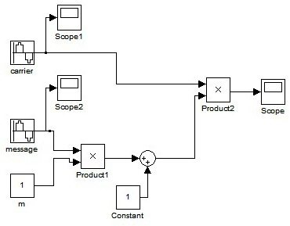
AM Generation using Simulink – Block Diagram
Block parameters can be changed by selecting the block and parameter:
- Carrier Signal frequency = 2*pi*25 and sampling time=1/5000
- Message Signal frequency = 2*pi and sampling time=1/5000
- Amplitudes of both signals are 1
Output Waveforms
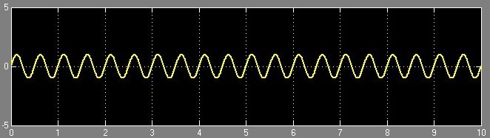
AM Generation using Simulink – Message Signal
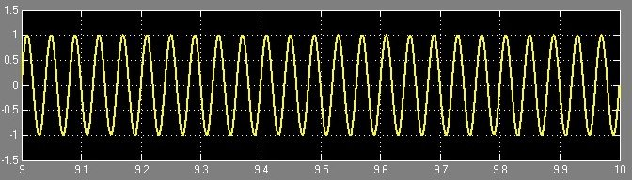
AM Generation using Simulink – Carrier
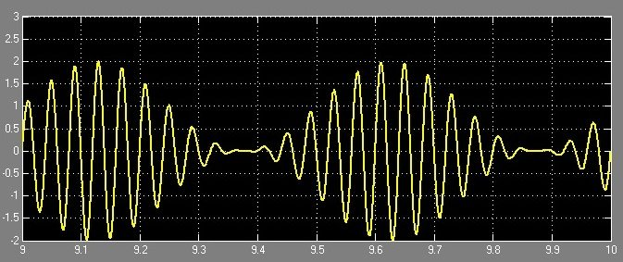
AM Generation using Simulink – Modulated Signal

Performance Task:
Implement the following demodulation in Simulink to retrieve the original signal:
You have a signal ‘m(t) = (2*sin(2*pi*4*t)+3*cos(2*pi*6*t))’. Apply amplitude modulation (AM) on the given signal with carrier signal ‘c(t) = cos(2*pi*50*t)’, and then do demodulation to recover the original message signal m(t).

Part-2
Title: Study of Frequency Modulation and Demodulation using Simulink (MATLAB)
Abstract:
This experiment is designed to-
- To understand the use of Simulink for solving communication engineering problems.
2.To develop understanding of Frequency Modulation and Demodulation using Simulink.
Theoretical Background:
If m(t) is message signal, the frequency modulated signal is expressed as in time domain:
$$s\left(t\right)= A_{c}cos⁡[2πf_{c}t+ K_{f}\int_{-∞}^{t}{m\left(λ\right)dλ}]$$

Frequency Demodulation
Phase Locked Loop (PLL) Demodulation: The PLL demodulates the FM signal using feedback force a Voltage-Controlled-Oscillator (VCO) to remain in phase with the carrier of the incoming signal. The message is recovered as the control input of the VCO [2]. In the simulation experiment (section-2), we used the VCO to demodulate the information signal.

Building Simulink Model of Frequency Modulation and Demodulation:
The frequency modulator and demodulator structures are as explained below. In the first model, you are provided a FM structure that is very similar to the theoretical background of this experiment. In the second model, you will observe the PLL frequency demodulator blocks provided by Simulink.
Frequency Modulation:
The Simulink model for FM modulator is:
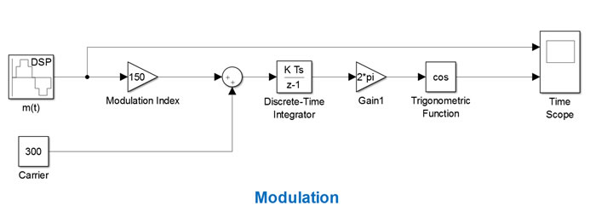Figure 1: Block Diagrams for the FM Modulator
The blocks’ parameters are as described below:
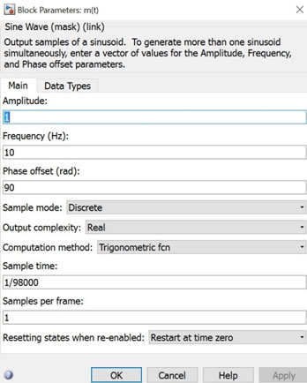
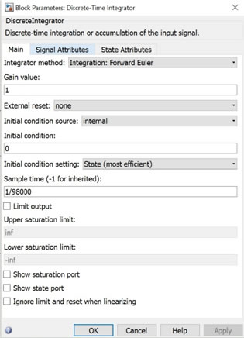
Figure 2: Blocks’ Parameters for FM Modulator
Adjust the simulation time about 0.2 sec to observe the waveforms precisely. The result in time scope will be:
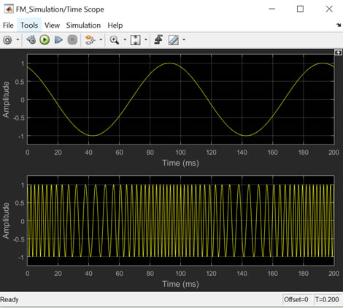
Figure 3: Time Scope

Frequency Modulator and Demodulator:
The Simulink model of the complete FM modulator and demodulator is shown next:

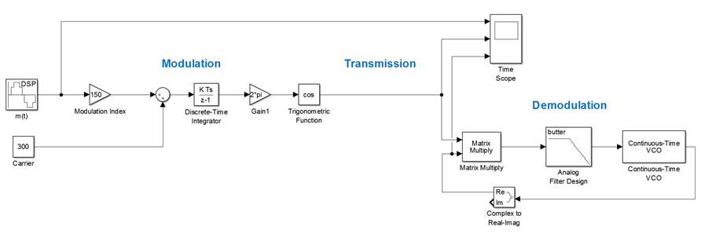

Figure 4: FM Modulator and Demodulator
You need to modify the filter and the VCO parameters as shown in the screenshots:
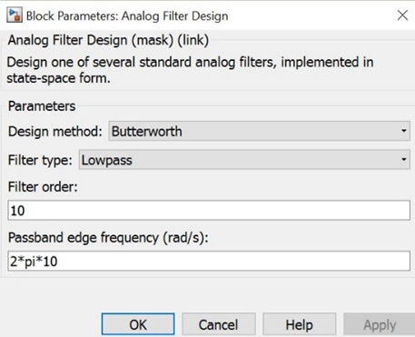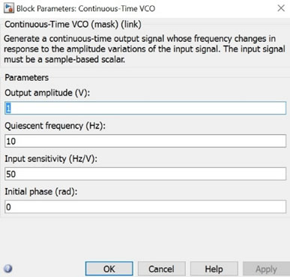
Figure 5:Block Parameters

Run your simulation and observe the signals in the time scope:
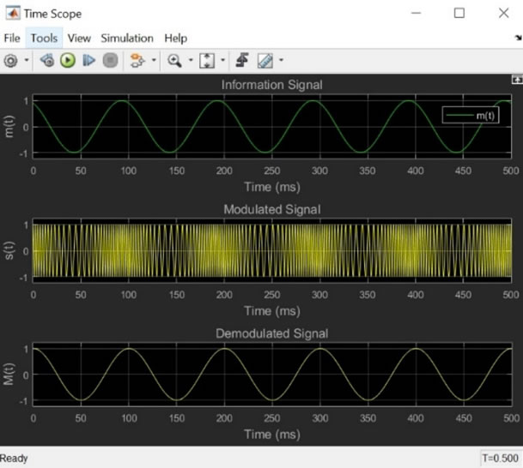
Figure 6: Time Scope for Model-1
As you can see, the FM modulated sinusoid is recovered in demodulation.
Performance Task:
Message signal, m(t) = a*sin(2πf_{m}t + π/3), a = 2, f_{m} = 10. Use FM modulation and demodulation on the given signal and use two scopes to show your output.
First scope should show message signal and modulated signal. Second scope should show message signal and demodulated signal.
Lab Report must contain (a) A block diagram of FM modulator, (b) A block diagram of FM demodulator, (c) A block diagram of FM modulator and demodulator in a single window, (d) Two scope figures.

